**University of the Cordilleras**

**College of Information Technology and Computer Science**

CC12 – Statistical Design and Analysis

**Colab LabAct4: Comparing Two Population Proportions**

Problem 1:

A swimming school wants to determine whether a recently hired instructor is working out. Sixteen out of 25 of Instructor A's students passed the lifeguard certification test on the first try. In comparison, 57 out of 72 of more experienced Instructor B's students passed the test on the first try. Is Instructor A's success rate worse than Instructor B's? Use α = 0.10.

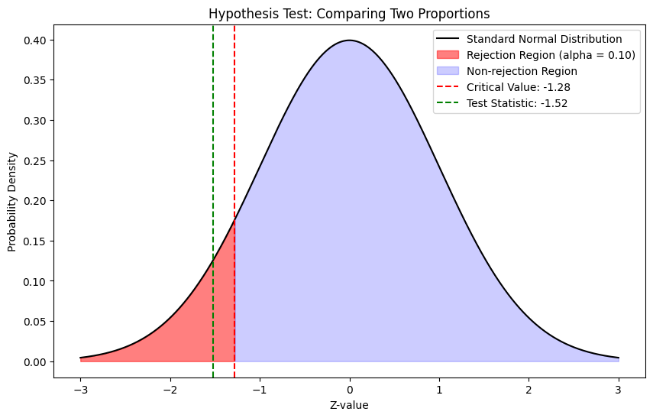**Curve**

**Test Statistic:** *-1.52*

**Critical Value**: -*1.28*

**Conclusion :**

There is sufficient evidence at the 10% level of significance to conclude that Instructor A's success rate is worse than Instructor B's.

Problem 2:

The department of code enforcement of a county government issues permits to general contractors to work on residential projects. For each permit issued, the department inspects the result of the project and gives a “pass” or “fail” rating. A failed project must be re-inspected until it receives a pass rating. The department had been frustrated by the high cost of re-inspection and decided to publish the inspection records of all contractors on the web. It was hoped that public access to the records would lower the re-inspection rate. A year after the web access was made public, two samples of records were randomly selected. One sample was selected from the pool of records before the web publication and one after. The proportion of projects that passed on the first inspection was noted for each sample. Out of 500 without public web access, 67% passed on the first inspection and out of 100 with public web access, 80% passed. Test whether there is sufficient evidence to conclude that public web access to the inspection records has increased the proportion of projects that passed on the first inspection by more than 5 percentage points. Use the critical value approach at the 10% level of significance.

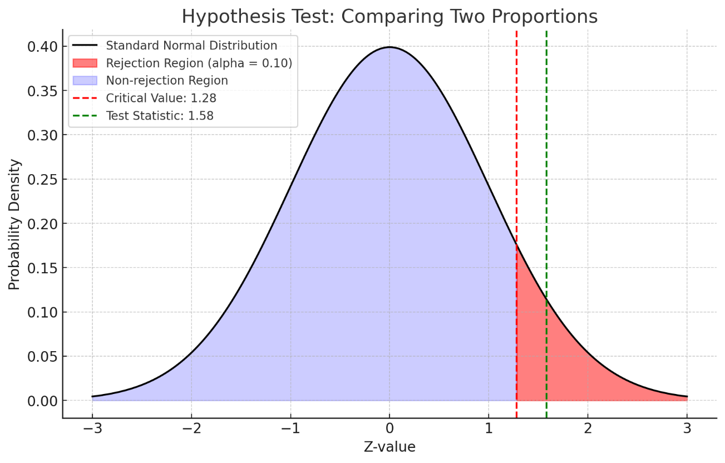

**Curve**

**Test Statistic:** *1.58*

**Critical Value:** *1.28*

**Conclusion**

Reject the null hypothesis. The test statistic falls in the rejection region. Therefore, there is sufficient evidence to conclude that public web access to the inspection records has increased the proportion of projects that passed on the first inspection by more than 5 percentage points at the 10% significance level.